LINENS PICTORIAL
BLACK & GOLD:
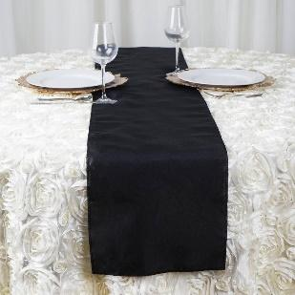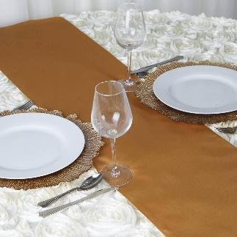
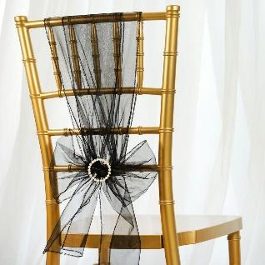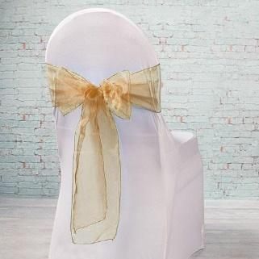
28 Black Table Runners
28 Gold Table Runners
91 Black Organza Chair Sashes
90 Gold Organza Chair Sashes

BROWN & CREAM:
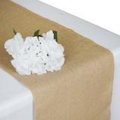 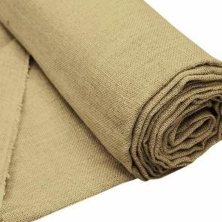 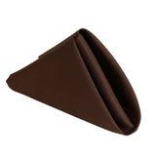 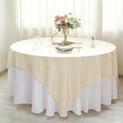 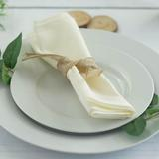
20 Burlap Table Runners
10.5 x 6 yds. Burlap Roll
21” x 10 yds. Burlap/Gold Roll
100 Chocolate Napkins
14 Cream Fabric Table Toppers
128 Cream Napkins

BURGUNDY:
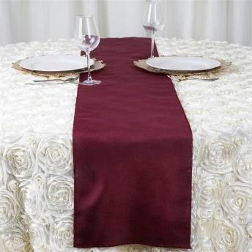 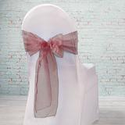 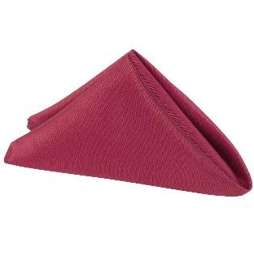 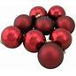
22 Table Runners
125 Organza Chair Sashes
105 Napkins
33 Christmas Balls

BURGUNDY LACE:
9 Rectangle Table Toppers
2 Long Rectangle Table Toppers (52x70)
12 Fabric Table Toppers (Round)

CANDY APPLE GREEN:
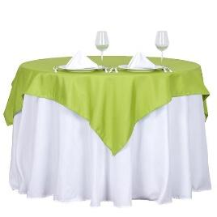 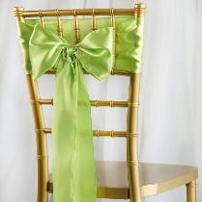
16 Fabric Table Toppers
100 Chair sashes

CORAL:
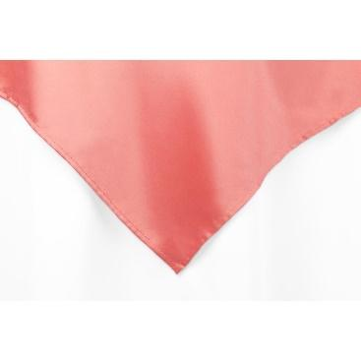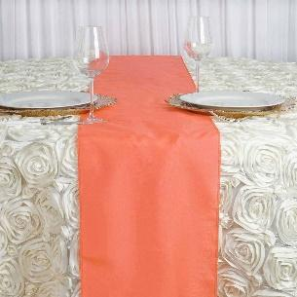
10 Fabric Table Toppers
25 Table Runners

IVORY:
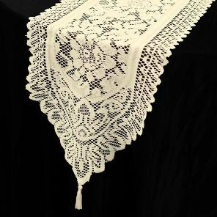
100 (+/-) Ivory Lace Chair Sashes

LAVENDER:
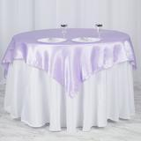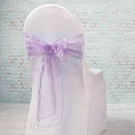
12 Fabric Table Toppers
98 Organza Chair Sashes

MISCELLANEOUS:
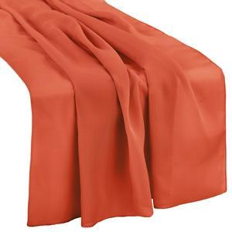 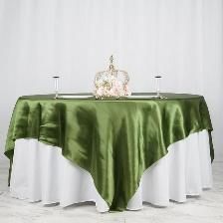 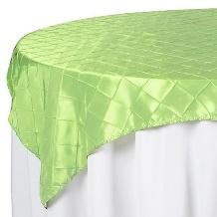
12 Rust Table Runners
1 Olive Table Topper
4 Chartreuse Table Toppers (yellowish/green)

NAVY:
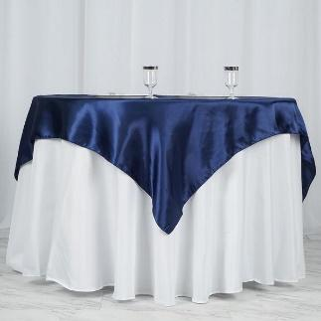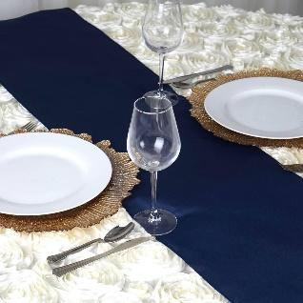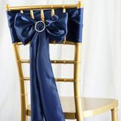
27 Fabric Table Toppers
3 Satin Table Runners
198 Satin Chair Sashes (Can be used as Runners also)

PINK:
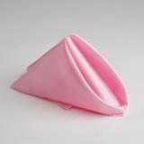
60 Pink Napkins

PLUM:
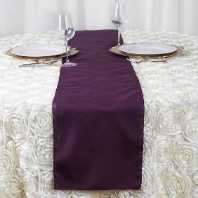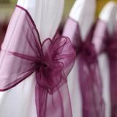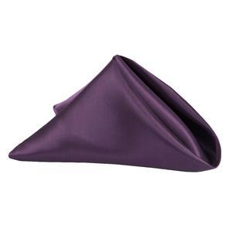
21 Table Runners
125 Organza Chair Sashes
126 Napkins
10 Long Pieces of Tulle

ROYAL BLUE:
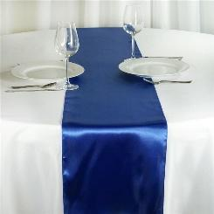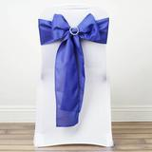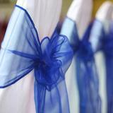
17 Royal Blue Satin Table Runners
20 Royal Blue Satin Chair Sashes
100 Royal Blue Organza Chair Sashes

SAGE:
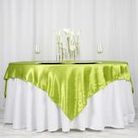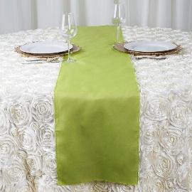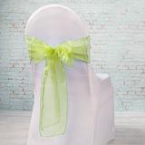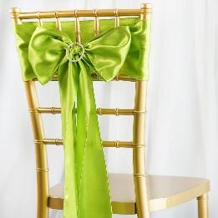
12 Fabric Table Toppers
8 Table Runners
10 Organza Chair Sashes
4 Fabric Chair Sashes

SILVER / GRAY:
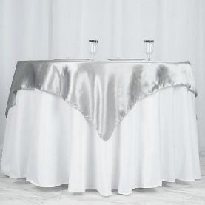 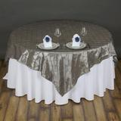 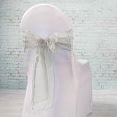 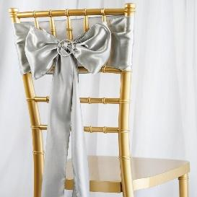
18 Plain Satin Table Toppers
16 Pintuck Silver-On-Silver Table Toppers
129 Organza Chair Sashes
10 Fabric Chair Sashes

TEAL:
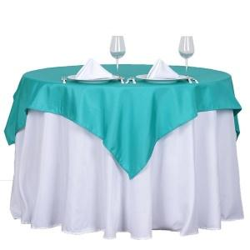 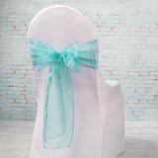
14 Fabric Table Toppers
100 Organza Chair Sashes

WHITE LACE:
12 Round Lace Tablecloths
3 Small Square Tablecloths
122 White Polyester Napkins

WHITE COTTON:
14 White Cotton Outdoor Rectangle Tablecloths (5 small / 9 large)
11 White Cotton Outdoor Round Tablecloths

TABLE RUNNERS:
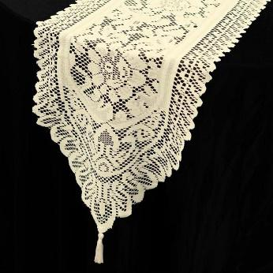
20 Narrow Center Lace Table Runners (Also can be used as underlays)

YELLOW:
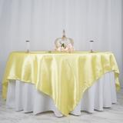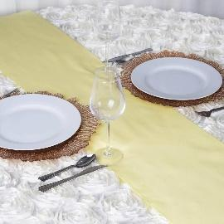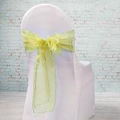
20 Canary Yellow Fabric Table Toppers
20 Pastel Yellow Table Runners
100 Pastel Yellow Organza Chair Sashes

Miscellaneous Items:
93 Cloth Placemats / Hay Seat Covers
63 Lace Placemats / Hay Seat Covers
10 Large Round White Table Doilies
99 Small Round Beige Table Doilies

See “Equipment Costs Worksheet” for pricing on all linens.

